PASSIVE COOLING SYSTEM FOR HOMES

A PROJECT REPORT

Submitted by

SRIDHAR.B | 611223114100
YOGESWARI.G | 611223114115
SHARATH.M.R | 611223114094
MAHENDIRAN.M | 611223114054

in partial fulfillment for the award of the degree
Of

BACHELOR OF ENGINEERING
IN
MECHANICAL ENGINEERING

KNOWLEDGE INSTITUTE OF TECHNOLOGY,SALEM

ANNA UNIVERSITY::CHENNAI 600 025

DEC 2025

BONAFIDE CERTIFICATE

Certified that this project report "PASSIVE COOLING FOR HOMES" is the bonafide work of "SRIDHAR.B ,SHARATH.M.R,YOGESWARI.G MAHENDIRAN.M" who carried out the project work under my supervision.

SIGNATURE SIGNATURE

Dr.K.S.PRABHAKARAN.,M.E.,Ph.D. Prof.S.SURENDAR.,B.E.,M.E.
HEAD OF THE DEPARTMENT SUPERVISOR
PROFESSOR ASSISTANT PROFESSOR
DEPARTMENT OF MECHANICAL DEPARTMENT OFMECHANICAL
ENGINEERING ENGINEERING
KNOWLEDGE INSTITUTE OF KNOWLEDGE INSTITUTE OF
TECHNOLOGY TECHNOLOGY
KIOT CAMPUS KIOT CAMPUS
KAKAPALAYAM(PO) KAKAPALAYAM(PO)
SALEM-637504 SALEM-637504

ABSTRACT

This project focuses on the design, implementation, and performance evaluation of a Passive Cooling System for Homes, aimed at lowering indoor temperatures using natural and low-cost methods such as thermal insulation, reflective materials, enhanced ventilation, and controlled heat exchange. To evaluate the effectiveness of the proposed passive cooling approach, an ESP32-based temperature monitoring system is developed. The system utilizes two DS18B20 digital temperature sensors, with one sensor placed inside the structure and the other outside to continuously monitor temperature variations.Temperature data is recorded at one-minute intervals using a Real-Time Clock (RTC) module and stored on an SD card for analysis. This enables accurate comparison of indoor and outdoor temperature behavior throughout different periods of the day.Experimental results demonstrate that the proposed passive cooling prototype achieves an indoor temperature reduction of approximately 5 to 7 °C compared to the outdoor environment, particularly during peak daytime hours. The indoor temperature is also observed to be more stable than the outdoor temperature. These findings confirm that passive cooling techniques can improve indoor thermal comfort while reducing dependence on electrical energy, offering a cost-effective, energy-efficient, and environmentally sustainable solution for residential buildings in tropical regions.

KEYWORDS:

Passive Cooling System, Residential Buildings, Tropical Climate, High-Temperature Regions, Energy-Efficient Buildings, Sustainable Cooling, Thermal Comfort, Indoor Temperature Reduction, Low-Energy Cooling.

TABLE OF CONTENT

CHAPTER NO. | TITLE | PAGE NO.
 | ABSTRACT | i
 | LIST OF TABLES | vii
 | LIST OF FIGURES | xii
 | LIST OF SYMBOLS & ABBREVIATIONS | vii
1 | INTRODUCTION | 1
 | 1.1 Overview of Passive Cooling | 1
 | 1.2 Energy Consumption in Residential Buildings | 2
 | 1.3 Need for Passive Cooling in Tropical Regions | 3
 | 1.4 Need for Continuous Monitoring System | 4
 | 1.5 Objectives of the Project | 5
 | 1.6 Methodology | 5
2 | LITERATURE SURVEY | 7
 | 2.1 Review of Passive Cooling Techniques | 9
 | 2.2 Thermal Comfort and Heat Transfer Studies | 10
 | 2.3 Natural Ventilation and Building Design | 10
 | 2.4 Reflective and Insulation Materials | 11
 | 2.5 Sensor-Based Temperature Monitoring Systems | 12
 | 2.6 Research Gap and Motivation | 12
3 | PASSIVE COOLING PRINCIPLES | 14
 | 3.1 Introduction | 14
 | 3.2 Natural Ventilation | 14
 | 3.3 Thermal Mass Effect | 15
 | 3.4 Reflective Surfaces | 16
 | 3.5 Shading Strategies | 16
 | 3.6 Heat Dissipation Mechanisms | 17
 | 3.7 Integrated Passive Cooling Approach | 17
4 | SYSTEM DESIGN AND COMPONENT DESCRIPTION | 19
 | 4.1 Introduction | 19
 | 4.2 Overall System Architecture | 19
 | 4.3 Block Diagram Description | 20
 | 4.4 Components List | 21
 | 4.5 Component Description | 21
 | 4.5.1ESP32 Microcontroller | 21
 | 4.5.2DS18B20 Temperature Sensors | 22
 | 4.5.3RTC Module (DS3231) | 23
 | 4.5.4SD Card Module | 24
 | 4.5.5Power Supply Unit | 25
 | 4.5.6Passive Cooling Structural Elements | 26
 | 4.6 Design Considerations | 27
 | 4.7 System Advantages | 27
5 | CIRCUIT DESIGN AND CONNECTIONS | 28
 | 5.1 Introduction | 28
 | 5.2 Circuit Diagram | 28
 | 5.3 Pin Configuration of ESP32 | 29
 | 5.4 Sensor Wiring and Connections | 29
 | 5.5 RTC Module Connections | 30
 | 5.6 SD Card Module Connections | 30
 | 5.7 Power Supply Arrangement | 31
 | 5.8 Circuit Reliability and Safety Measures | 31
6 | WORKING PRINCIPLE | 32
 | 6.1 Introduction | 32
 | 6.2 Heat Transfer Mechanism in Passive Cooling | 32
 | 6.3 Passive Cooling Operation | 33
 | 6.4 Temperature Sensing Process | 33
 | 6.5 Data Logging and Time Synchronization | 34
 | 6.6 System Operation Flow | 34
7 | EXPERIMENTAL SETUP AND IMPLEMENTATION | 35
 | 7.1 Introduction | 35
 | 7.2 Description of Experimental Model | 35
 | 7.3 Integration of Passive Cooling Techniques | 36
 | 7.4 Temperature Sensor Installation | 37
 | 7.5 Hardware Setup | 37
 | 7.6 Software Implementation | 37
 | 7.7 Calibration and Testing | 38
 | 7.8 Experimental Procedure | 38
 | 7.9 Data Collection and Analysis Preparation | 38
8 | COST ESTIMATION | 40
 | 8.1 Introduction | 40
 | 8.2 Cost Estimation Methodology | 40
 | 8.3 Component-Wise Cost Breakdown | 41
 | 8.4 Economic Feasibility | 41
 | 8.5 Cost Comparison with Conventional Cooling Systems | 42
9 | RESULTS AND ANALYSIS | 43
 | 9.1 Introduction | 43
 | 9.2 Temperature Data Collection | 43
 | 9.3 Indoor and Outdoor Temperature Comparison | 44
 | 9.4 Performance During Peak Temperature Hours | 45
 | 9.5 Temperature Stability Analysis | 45
 | 9.6 Graphical Representation of Results | 45
 | 9.7 Effectiveness of Individual Passive Cooling Techniques | 46
 | 9.8 Energy Saving Potential | 46
 | 9.9 Limitations of the Experiment | 46
10 | ADVANTAGES AND APPLICATIONS | 47
 | 10.1 Introduction | 47
 | 10.2 Advantages of Passive Cooling System | 47
 | 10.3 Energy Efficiency | 47
 | 10.22Cost Effectiveness | 47
 | 10.2.3Environmentally Friendly | 48
 | 10.2.4Improved Thermal Comfort | 48
 | 10.2.5Low Maintenance Requirements | 48
 | 10.2.6Scalability and Adaptability | 48
 | 10.3 Applications of Passive Cooling System | 48
 | 10.3.1Residential Buildings | 48
 | 10.3.2Rural and Low-Income Housing | 49
 | 10.3.3Commercial Buildings | 49
 | 10.3.4Educational Institutions | 49
 | 10.3.5Industrial and Storage Buildings | 49
11 | APPENDICES | 50
 | 11.1FIELD VISIT | 50
 | 11.2 PROTOTYPE | 51
12 | CONCLUSION | 52
13 | REFERENCES | 53

LIST OF TABLES

Table No. | Title | Page No.
Table 4.4 | List of Components | 36
Table 5.3 | ESP32 Pin Configuration | 44
Table 7.2 | Experimental Setup Details | 50
Table 8.3 | Cost Estimation of Components | 56
Table 9.2 | Temperature Data Collection | 58

LIST OF SYMBOLS, ABBREVIATIONS AND NOMENCLATURE

1.SYMBOLS:

Symbol | Meaning
°C | Degrees Celsius
V | Voltage (Volts)
mA | Milliampere
kΩ | Kilo Ohms
MHz | Megahertz
GB | Gigabyte
W | Watts

2.ABBREVIATIONS:

Abbreviation | Full Form
ESP | Espressif Systems Processor
RTC | Real-Time Clock
SD | Secure Digital
I2C | Inter-Integrated Circuit
GPIO | General Purpose Input/Output
SPI | Serial Peripheral Interface
CSV | Comma Separated Values
ADC | Analog to Digital Converter
HVAC | Heating, Ventilation, and Air Conditioning

3.NOMENCLATURE:

Term | Definition / Description
Passive Cooling System | Cooling approach that reduces indoor temperature using natural heat dissipation methods without mechanical devices
Residential Buildings | Structures designed primarily for human habitation
Tropical Climate | Climate characterized by high temperatures and humidity throughout the year
High-Temperature Regions | Geographic areas that experience consistently elevated ambient temperatures
Energy-Efficient Buildings | Buildings designed to minimize energy consumption while maintaining occupant comfort
Sustainable Cooling | Cooling methods that reduce environmental impact and energy use
Thermal Comfort | Condition in which occupants feel satisfied with the indoor thermal environment
Indoor Temperature Reduction | Process of lowering internal building temperature to improve comfort
Low-Energy Cooling | Cooling techniques requiring minimal electrical energy
Natural Ventilation | Airflow through buildings driven by wind and temperature differences
Thermal Insulation | Materials or techniques that reduce heat transfer between indoor and outdoor environments
Reflective Materials | Materials that reflect solar radiation to reduce heat absorption
Heat Gain Reduction | Strategies aimed at minimizing unwanted heat entering a building
Heat Transfer Control | Regulation of heat flow through building components
Passive Heat Exchange | Heat transfer process occurring naturally without external power
Building Envelope Optimization | Enhancement of walls, roofs, and openings to improve thermal performance
Climate-Responsive Design | Architectural design adapted to local climate conditions
Sustainable Architecture | Architectural practices focused on environmental responsibility
Green Buildings | Structures designed to reduce environmental impact and enhance energy efficiency
Eco-Friendly Cooling | Cooling solutions that are environmentally sustainable
Energy Conservation | Reduction of energy consumption through efficient design and operation
Electrical Energy Reduction | Minimization of electrical power usage in building systems
Carbon Emission Reduction | Decrease in greenhouse gas emissions through sustainable practices
Environmental Sustainability | Responsible interaction with the environment to avoid resource depletion
Cost-Effective Cooling Solutions | Cooling methods that provide comfort at minimal financial cost
Low-Cost Housing Technologies | Affordable construction technologies for residential buildings
Passive Design Strategies | Design techniques that utilize natural energy flows
Building Thermal Performance | Ability of a building to regulate heat effectively
Indoor–Outdoor Temperature Analysis | Comparison of internal and external temperature variations
Temperature Stability | Maintenance of consistent indoor temperature levels
Thermal Regulation | Control of heat flow to maintain comfort
Heat Dissipation Mechanisms | Processes through which excess heat is released
Real-Time Temperature Monitoring | Continuous observation of temperature as it changes
ESP32 Microcontroller | A low-power, high-performance microcontroller used for data acquisition and processing
DS18B20 Temperature Sensor | Digital sensor used for accurate temperature measurement
Digital Temperature Measurement | Temperature sensing using digital output signals
Sensor-Based Monitoring System | System that collects environmental data using sensors
Real-Time Clock (RTC) | Module that keeps track of current date and time
Time-Stamped Data Logging | Recording sensor data with corresponding time information
SD Card Data Storage | Storage of logged data on a removable memory card
High-Resolution Temperature Data | Temperature data recorded with fine precision
One-Minute Interval Logging | Recording temperature data at one-minute time intervals
Experimental Performance Evaluation | Assessment of system effectiveness through experiments
Prototype Development | Creation of a working model to test system functionality
Residential Cooling Prototype | Experimental model developed for residential cooling applications
Data-Driven Thermal Analysis | Analysis of thermal behavior based on collected data
Peak Daytime Temperature Reduction | Reduction of maximum indoor temperature during daytime
Sustainable Residential Design | Housing design that emphasizes energy efficiency and sustainability

LIST OF FIGURES:

Figure No. | Title | Page No
Figure 4.1 | ESP32 Microcontroller | 37
Figure 4.2 | DS18B20 Temperature Sensors | 38
Figure 4.3 | RTC Module (DS3231) | 39
Figure 4.4 | SD Card Module | 40
Figure 4.4 | Power Supply Unit | 41
Figure 9.1 | Data collection
Figure 11.1 | Field visit | 66
Figure 11.2 | Field visit | 66
Figure 11.3 | Field visit | 66
Figure 11.4 | Prototype | 67
Figure 11.5 | Prototype | 67
Figure 11.6 | Prototype | 67

CHAPTER 1
INTRODUCTION

Rapid urbanization and increasing global temperatures have resulted in a tremendous rise in the demand for air-conditioning systems in residential buildings. In tropical countries such as India, the majority of homes rely heavily on mechanical cooling devices to maintain indoor thermal comfort. However, these systems consume large amounts of electricity and significantly contribute to environmental pollution and greenhouse gas emissions. The problem is further aggravated by frequent power shortages and rising energy costs.

Passive cooling is an effective and sustainable alternative to conventional air-conditioning systems. It refers to the use of natural heat flow processes such as conduction, convection, radiation, evaporation, and ventilation to maintain a comfortable indoor environment without the use of mechanical devices. Passive cooling techniques focus on minimizing heat gain from the environment and maximizing natural heat dissipation.

This project titled Passive Cooling for Homes – A Sustainable Approach for Thermal Comfort aims to study, analyze and propose various passive cooling strategies that can be effectively applied in residential buildings. The project highlights how intelligent architectural design, suitable material selection and effective utilization of climatic conditions can significantly reduce indoor temperature and energy consumption.

  - Overview of Passive Cooling
The rapid growth of urbanization and population has led to a significant increase in energy consumption in residential buildings. One of the major contributors to this energy demand is the extensive use of mechanical cooling systems such as air conditioners, air coolers, and electric fans to maintain indoor thermal comfort. In tropical and subtropical regions, where high ambient temperatures prevail for most of the year, cooling loads account for a substantial portion of household electricity consumption.

Passive cooling refers to a set of design strategies and techniques that reduce indoor temperatures and improve thermal comfort without relying on mechanical or electrical cooling systems. These techniques utilize natural processes such as heat conduction, convection, radiation, and evaporation to minimize heat gain and enhance heat dissipation. Passive cooling methods are integrated into the building design and envelope, making them energy-efficient, environmentally friendly, and cost-effective.

Unlike active cooling systems, passive cooling does not require continuous power input, complex machinery, or high maintenance. Instead, it relies on architectural planning, material selection, and natural climatic conditions. Common passive cooling strategies include natural ventilation, thermal mass utilization, reflective roofing, shading devices, insulation, and night-time heat release. These methods help in maintaining lower indoor temperatures and reducing temperature fluctuations throughout the day

  - Energy Consumption in Residential Buildings
Residential buildings contribute significantly to global and national energy consumption. In developing countries such as India, the demand for electricity in the residential sector has increased rapidly due to rising living standards, increased use of electrical appliances, and growing dependence on air conditioning systems. According to energy studies, cooling alone can account for 40–60% of the total electricity consumption in urban households during summer months.

The excessive use of air conditioning systems results in high electricity bills and places a heavy load on power grids, especially during peak demand hours. Furthermore, most conventional cooling systems operate using refrigerants that contribute to greenhouse gas emissions, thereby intensifying global warming and climate change. The increasing cost of energy and environmental concerns highlight the urgent need for sustainable alternatives to conventional cooling methods.

Reducing cooling energy demand in residential buildings not only lowers operational costs but also contributes to energy conservation and environmental protection. Passive cooling techniques offer an effective solution by minimizing heat gain at the source and reducing the need for mechanical cooling, thereby promoting sustainable building practices.

  - Need for Passive Cooling in Tropical Regions
Tropical regions are characterized by high ambient temperatures, intense solar radiation, and relatively high humidity levels. In such climatic conditions, maintaining indoor thermal comfort becomes a major challenge, especially in low-income and energy-constrained areas. Traditional buildings often experience excessive heat gain through roofs, walls, and windows, leading to uncomfortable indoor environments.

Passive cooling techniques are particularly suitable for tropical climates, as they are designed to mitigate heat gain and enhance natural airflow. Strategies such as reflective roofing materials reduce solar heat absorption, while cross-ventilation facilitates heat removal by promoting air movement. Thermal mass elements help in absorbing excess heat during the daytime and releasing it during cooler night hours, thereby stabilizing indoor temperatures.

By adopting passive cooling methods, buildings can achieve significant reductions in indoor temperature without increasing energy consumption. This makes passive cooling an ideal solution for tropical regions, where sustainable and affordable cooling solutions are essential to improve living conditions and reduce dependence on energy-intensive cooling systems.

  - Need for Continuous Monitoring System
To evaluate the effectiveness of passive cooling techniques, it is essential to monitor indoor and outdoor temperature variations continuously. Temperature monitoring provides quantitative data that helps in analyzing the thermal performance of the building and the efficiency of passive cooling strategies. Without proper monitoring, it becomes difficult to validate the actual benefits of passive cooling systems.

A continuous monitoring system enables real-time measurement of temperature changes and helps in understanding the thermal behavior of the structure throughout the day. By comparing indoor and outdoor temperatures at regular intervals, the impact of passive cooling methods can be accurately assessed. Data logging also allows long-term analysis, identification of peak temperature periods, and performance comparison under different environmental conditions.

In this project, an embedded system-based temperature monitoring setup is developed using digital temperature sensors and a microcontroller. The collected data is stored for further analysis, providing a reliable and systematic approach to evaluate the performance of the passive cooling system.

1.5 Objectives of the Project
The primary objective of this project is to design and evaluate a passive cooling system for residential buildings that reduces indoor temperature and improves thermal comfort while minimizing energy consumption. The specific objectives of the project are as follows:
- To study various passive cooling techniques suitable for residential buildings.
- To design a prototype model incorporating effective passive cooling strategies.
- To develop a temperature monitoring system for measuring indoor and outdoor temperatures.
- To analyze the temperature data and compare indoor and outdoor thermal performance.
- To evaluate the effectiveness of passive cooling methods in reducing indoor temperature.
- To promote energy-efficient and sustainable cooling solutions for homes.

1.6Methodology
The methodology adopted in this project involves both theoretical analysis and experimental evaluation. Initially, a detailed literature survey is conducted to understand existing passive cooling techniques and their applications in residential buildings. Based on the findings, suitable passive cooling methods are selected and integrated into the design of a prototype model.

An embedded temperature monitoring system is developed using an ESP32 microcontroller and DS18B20 temperature sensors. One sensor is placed inside the prototype structure, while another is positioned outside to measure ambient temperature. The temperature data is recorded at regular intervals using a real-time clock (RTC) module and stored on an SD card for further analysis.
The collected data is analyzed to compare indoor and outdoor temperature variations and evaluate the performance of the passive cooling system. The results are presented in graphical and tabular formats, and conclusions are drawn based on the observed temperature reduction and system efficiency.

CHAPTER 2
LITERATURE SURVEY

1. Research Years Covered (2000 – 2025) — Additional Recent Trends

2022–2025: Emerging High‑Performance Passive Cooling & Smart Materials
Shift from purely traditional passive design (ventilation, shading, thermal mass) to advanced materials and coatings that enable radiative cooling and dynamic thermal regulation.

Growing use of smart envelopes and hybrid systems, integrating passive cooling with photovoltaics, material emissivity control, and phase‑change storage.
Increased experimental and field‑scale studies assessing passive cooling in real buildings under varied climates.

Broader focus on sustainability, life‑cycle energy savings, and adaptability to urban heat‑island conditions.

2.Papers and Authors (2022–2025) – Selected Recent Works

Year Paper / Study (selected) Key Focus / Contribution
2022 “Passive radiant cooling without sacrificing the aesthetics of objects” — Dereń et al. 2022 Demonstrates radiative‑cooling materials that maintain aesthetic appearance while enabling passive thermal regulation.

2022 (published 2023) “Radiative cooling for passive thermal management towards sustainable carbon neutrality” — Review in National Science Review Reviews photonic‑structure based radiative cooling materials & discusses future potential for zero‑energy cooling strategies

2023 “Passive radiative cooling to sub-ambient temperatures inside naturally ventilated buildings” — (Cell Reports Physical Science, Sept 2023) Shows that combining radiative cooling with natural ventilation and thermal mass can maintain sub‑ambient indoor temperatures without active cooling.

2023 “A newly designed BIPV system with enhanced passive cooling and ventilation” — Ahmadi Moghaddam et al., 2023 Explores building-integrated photovoltaics (BIPV) combined with passive ventilation — integrating solar energy + passive cooling/ventilation.

2023 “Highly emissive, selective and omnidirectional thermal emitters mediated by machine learning for ultrahigh performance passive radiative cooling” — Zhang et al., 2023 Uses ML‑designed metasurface emitters to achieve high emissivity and selective infrared emission — enabling temperature reductions up to ~15.4 °C under strong solar loads.

2024 “An advanced passive radiative cooling emitter with ultrahigh sub-ambient cooling performance” — (Journal of Materials Chemistry A, 2024) Reports a surface coating with ~95.5% visible reflectance and ~97.9% mid‑IR emissivity, achieving average temperature reductions of ~20.1 °C and high cooling power (~121 W/m²).

2024 “Advancing sustainable building through passive cooling with phase change materials — a comprehensive literature review” — 2024 Surveys recent PCM‑based passive cooling applications, showing potential energy savings and improved thermal regulation when integrated in building envelopes.

2024 Evaluating the effectiveness of the ‘eco-cooler’ for passive home cooling” Bunker et al., 2024 (npj Climate Action) Explores a passive cooling system for homes (eco‑cooler), assessing performance under realistic residential conditions.

2024–2025 “Performance study of building cooling system composed of photovoltaic panels, PCM, and thermoelectric cooler: impact of its orientation” — International Journal of Air‑Conditioning and Refrigeration, 2025
Investigates a hybrid system: PV + PCM + thermoelectric cooling — showing how orientation impacts cooling performance in a passive/hybrid design.

2.1 Review of Passive Cooling Techniques
Passive cooling has been widely researched as a sustainable alternative to conventional mechanical cooling systems. Several studies highlight that passive cooling techniques can significantly reduce indoor temperatures by minimizing heat gain and enhancing natural heat dissipation mechanisms. Researchers have emphasized that building orientation, material selection, and architectural design play a crucial role in achieving effective passive cooling.

Studies conducted on residential buildings in hot and dry as well as hot and humid climates show that techniques such as natural ventilation, thermal insulation, reflective roofing, and shading devices can reduce indoor temperatures by 4–8 °C. These methods are particularly effective when integrated during the building design stage rather than added as retrofitting solutions. Literature also suggests that passive cooling strategies are most effective when multiple techniques are combined rather than applied individually.

Several authors have concluded that passive cooling not only improves thermal comfort but also reduces electricity consumption and carbon emissions. These findings establish passive cooling as a viable and environmentally sustainable approach for residential buildings.

2.2 Thermal Comfort and Heat Transfer Studies
Thermal comfort is a critical factor in evaluating the performance of passive cooling systems. Researchers have extensively studied the relationship between indoor temperature, humidity, air velocity, and human comfort. According to ASHRAE standards, thermal comfort depends on both environmental parameters and human factors such as clothing and activity level.

Heat transfer studies indicate that conduction through roofs and walls accounts for the majority of heat gain in residential buildings. Several experiments have demonstrated that roofs alone can contribute up to 60% of the total heat entering a building. Therefore, reducing conductive heat transfer through proper insulation and reflective materials is essential for effective passive cooling.

Research also highlights the importance of convective and radiative heat transfer in indoor environments. Proper ventilation enhances convective heat removal, while reflective surfaces reduce radiative heat absorption. These studies provide a scientific foundation for designing passive cooling systems based on fundamental heat transfer principles.

2.3 Natural Ventilation and Building Design
Natural ventilation is one of the most commonly studied passive cooling techniques. Literature shows that effective ventilation can significantly improve indoor air quality and thermal comfort by promoting air circulation and removing accumulated heat. Cross-ventilation, stack ventilation, and wind-driven ventilation are the most widely discussed natural ventilation methods.

Researchers emphasize that window placement, size, and orientation greatly influence ventilation performance. Buildings designed with openings on opposite walls enable cross-ventilation, allowing fresh air to enter and warm air to exit. Stack ventilation utilizes temperature-induced density differences to drive airflow, which is particularly effective in multi-storey buildings.

Studies conducted in tropical regions indicate that natural ventilation can reduce indoor temperatures by 2–4 °C when properly implemented. However, literature also notes that ventilation effectiveness depends on external climatic conditions such as wind speed and direction.

2.4 Reflective and Insulation Materials
The use of reflective and insulation materials has been extensively explored in passive cooling research. Reflective materials, such as white or aluminum coated roofing sheets, reduce solar heat gain by reflecting a large portion of incident solar radiation. Studies report that high-albedo roofing materials can lower roof surface temperatures by 20–30 °C compared to conventional materials.

Thermal insulation materials such as thermocol , polyurethane foam, and mineral wool have been shown to significantly reduce heat transfer through building envelopes. Experimental studies indicate that insulated roofs and walls can reduce indoor temperatures by 3–6 °C during peak summer conditions.

Literature also discusses the importance of material thickness, thermal conductivity, and durability in selecting suitable insulation materials. Low-cost and locally available materials are recommended for residential applications to ensure economic feasibility.

2.5 Sensor-Based Temperature Monitoring Systems
Recent research highlights the growing use of embedded systems and sensor technologies for monitoring thermal performance in buildings. Digital temperature sensors such as DS18B20, DHT22, and LM35 are commonly used due to their accuracy, ease of integration, and low cost.

Several studies demonstrate the effectiveness of microcontroller-based data acquisition systems in recording temperature variations at regular intervals. Systems using Arduino, ESP8266, and ESP32 platforms have been widely reported in literature for building energy studies. The inclusion of real-time clock (RTC) modules ensures accurate time-stamping of data, while SD card modules enable long-term data storage.

Researchers conclude that continuous temperature monitoring provides reliable and high-resolution data for evaluating passive cooling performance. These systems allow for detailed analysis of indoor and outdoor temperature trends and help validate the effectiveness of passive cooling strategies.

2.6 Research Gap and Motivation
Although extensive research has been conducted on individual passive cooling techniques, literature reveals a gap in integrated experimental studies that combine multiple passive cooling methods with real-time monitoring in small-scale residential prototypes. Many studies rely on simulations rather than physical experiments, limiting practical validation.

Additionally, there is limited research focusing on low-cost, easily implementable passive cooling solutions suitable for developing countries and rural housing. The lack of continuous temperature data logging in many studies further restricts detailed performance analysis.

This project addresses these research gaps by developing a low-cost passive cooling prototype integrated with a sensor-based temperature monitoring system. The study aims to provide experimental validation of passive cooling effectiveness and promote practical, energy efficient cooling solutions for residential buildings.

CHAPTER 3
PASSIVE COOLING PRINCIPLES

3.1 Introduction
Passive cooling principles involve design strategies that reduce indoor temperatures and improve thermal comfort without using mechanical or electrical cooling systems. These strategies rely on natural processes such as ventilation, shading, thermal mass, and reflective surfaces to control heat gain and promote heat dissipation. Passive cooling is particularly suitable for hot and tropical climates and helps maintain comfortable indoor conditions in an energy-efficient manner.

By reducing dependence on air-conditioning, passive cooling lowers energy consumption, decreases greenhouse gas emissions, and cuts operational costs. It supports sustainable building practices by extending building lifespan and minimizing environmental impact, making it an important approach in designing climate-responsive and energy-efficient homes.

3.2 Natural Ventilation
Natural ventilation is one of the most effective and widely used passive cooling principles. It involves the movement of fresh outdoor air into a building and the removal of warm indoor air without the use of mechanical devices. This airflow helps reduce indoor temperature, removes accumulated heat, and improves indoor air quality.

Natural ventilation operates mainly through two mechanisms: wind-driven ventilation and buoyancy-driven (stack) ventilation. Wind-driven ventilation occurs due to pressure differences created by wind flowing around a building, allowing air to enter through openings such as windows and vents. Stack ventilation occurs due to temperature-induced density differences, where warm air rises and exits through higher openings while cooler air enters from lower openings.

Proper placement and sizing of windows, doors, and ventilators are crucial for effective natural ventilation. Cross-ventilation, achieved by placing openings on opposite walls, significantly enhances airflow and cooling efficiency. Studies show that well-designed natural ventilation can reduce indoor temperature by 2–4 °C in tropical climates.

3.3 Thermal Mass Effect
Thermal mass refers to the ability of a material to absorb, store, and release heat over time. Materials with high thermal mass, such as concrete, brick, stone, and mud, can absorb excess heat during the daytime and release it during cooler night hours. This process helps stabilize indoor temperatures and reduce peak heat loads.

The thermal mass effect is based on the principle of heat storage and time lag. When exposed to solar radiation, high thermal mass materials delay heat transfer into indoor spaces, resulting in lower indoor temperatures during peak daytime hours. At night, when outdoor temperatures decrease, the stored heat is gradually released to the surroundings.

Effective utilization of thermal mass requires proper ventilation, especially during nighttime, to remove the released heat. Literature suggests that buildings incorporating thermal mass can experience indoor temperature reductions of 3–5 °C compared to lightweight structures.

3.4 Reflective Surfaces
Reflective surfaces play a critical role in reducing solar heat gain in buildings. These surfaces reflect a significant portion of incoming solar radiation, thereby minimizing heat absorption. Roofs and external walls are the primary targets for reflective treatments, as they receive the highest solar exposure.

High-albedo materials such as white paint, aluminum foil, and reflective coatings are commonly used to enhance reflectivity. Studies indicate that reflective roofing can reduce roof surface temperatures by up to 20–30 °C, which directly contributes to lower indoor temperatures.

The effectiveness of reflective surfaces depends on their reflectivity, durability, and maintenance. Clean and well-maintained reflective surfaces provide consistent performance over time. The use of reflective materials is a cost-effective passive cooling strategy, especially suitable for tropical regions.

3.5 Shading Strategies
Shading is a passive cooling principle that reduces direct solar radiation entering a building. By blocking or filtering sunlight before it reaches walls, windows, and roofs, shading minimizes heat gain and improves indoor comfort.
Common shading devices include overhangs, louvers, awnings, pergolas, vegetation, and external blinds. Fixed shading devices are designed based on the sun’s path, while movable shading allows flexibility according to seasonal variations. Vegetation-based shading, such as trees and green walls, also contributes to cooling through evapotranspiration.

Research shows that effective shading can reduce indoor temperatures by 2–3 °C and significantly lower cooling energy demand. Properly designed shading devices are especially important for windows, as they are major pathways for solar heat gain.

3.6 Heat Dissipation Mechanisms
Heat dissipation is the process of removing accumulated heat from a building to the surrounding environment. In passive cooling systems, heat dissipation occurs through conduction, convection, radiation, and evaporation.

Conduction involves heat transfer through building materials, which can be minimized using insulation. Convection occurs when warm air is replaced by cooler air through ventilation. Radiative cooling allows heat to be released from building surfaces to the cooler night sky, particularly effective in clear-sky conditions. Evaporative cooling utilizes the cooling effect produced during water evaporation, commonly achieved through water bodies or porous materials.

Combining these heat dissipation mechanisms enhances the overall effectiveness of passive cooling systems. Literature indicates that optimized heat dissipation strategies can significantly reduce indoor temperature fluctuations and improve thermal comfort without energy consumption.

3.7 Integrated Passive Cooling Approach
An integrated passive cooling approach combines multiple passive cooling principles to achieve maximum thermal comfort. Rather than relying on a single technique, the combined use of ventilation, thermal mass, reflective surfaces, shading, and heat dissipation provides synergistic benefits.

Integrated systems are more adaptable to varying climatic conditions and building usage patterns. Studies show that buildings employing integrated passive cooling strategies can achieve indoor temperature reductions of 5–7 °C compared to conventional buildings.

This project adopts an integrated passive cooling approach by incorporating reflective materials, insulation, controlled ventilation, and real-time temperature monitoring. The integration of these principles ensures effective cooling performance and provides experimental validation of passive cooling benefits.

Key Takeaways from Passive Cooling Principles
- Passive cooling relies on natural heat transfer mechanisms
- Roof and wall treatments play a major role in heat reduction
- Combined passive strategies are more effective than individual methods
- Passive cooling improves comfort with zero or minimal energy use

CHAPTER 4
SYSTEM DESIGN AND COMPONENT DESCRIPTION

4.1Introduction
This chapter presents the detailed system design and component description of the proposed passive cooling system for residential buildings. The system design defines the overall architecture, functional layout, and integration of passive cooling techniques with an embedded temperature monitoring setup. Emphasis is placed on the selection of suitable components, their operational principles, and their interconnections to ensure efficient thermal performance and reliable data acquisition.

The chapter explains how structural passive cooling elements such as reflective roofing, insulation, ventilation, and shading are combined with electronic components including temperature sensors, a microcontroller, and data logging modules. A systematic description of each component is provided to justify its selection based on performance, reliability, cost, and suitability for residential applications. This comprehensive design approach ensures effective evaluation of indoor and outdoor temperature variations and demonstrates the practical feasibility of the proposed passive cooling system.

4.2 Overall System Architecture
The system design of the proposed passive cooling system integrates structural passive cooling elements with an embedded temperature monitoring system to evaluate thermal performance. The primary objective of the system architecture is to reduce indoor heat gain using passive methods and to continuously monitor temperature variations inside and outside the structure.
The overall system consists of two major subsystems:
- Passive Cooling Structural System, which includes reflective roofing, insulation layers, ventilation openings, and shading elements.
- Temperature Monitoring and Data Logging System, which includes sensors, a microcontroller, data storage, and power supply units.
The indoor and outdoor temperatures are measured simultaneously using digital temperature sensors. The sensor data is processed by a microcontroller and recorded with time stamps for further analysis. This integrated architecture enables accurate performance evaluation of the passive cooling system under real-time environmental conditions.

4.3 Block Diagram Description
The block diagram of the system illustrates the functional relationship between different components. Two temperature sensors are placed at different locations: one inside the structure and the other outside to measure ambient temperature. These sensors are connected to an ESP32 microcontroller, which serves as the central processing unit.

A Real-Time Clock (RTC) module is interfaced with the ESP32 to provide accurate time information for data logging. The processed temperature data, along with time stamps, is stored in an SD card module for long-term analysis. The entire system is powered using a regulated power supply unit.
The block diagram clearly shows the flow of data from sensors to storage, ensuring systematic monitoring and analysis of temperature variation

4.4 Components List
LIST OF COMPONENTS:
S. No. | Component Name | Description / Purpose
1 | ESP32 Microcontroller | Main control unit for data acquisition and processing
2 | DS18B20 Digital Temperature Sensors (2 Nos.) | Measures temperature at two different points
3 | RTC Module (DS3231) | Provides accurate real-time date and time
4 | SD Card Module | Stores logged temperature data
5 | Power Supply Unit | Supplies required power to the system
6 | Connecting Wires and Breadboard | Used for circuit connections and prototyping

4.5 Component Description
4.5.1 ESP32 Microcontroller
The ESP32 is a powerful, low-cost microcontroller with integrated Wi-Fi and Bluetooth capabilities. It is selected for this project due to its high processing speed, low power consumption, and multiple GPIO pins. The ESP32 processes temperature data received from the sensors and controls data logging operations.

The microcontroller supports digital communication protocols such as I²C and SPI, which are used to interface the RTC and SD card modules. Its reliability and flexibility make it suitable for continuous temperature monitoring applications.
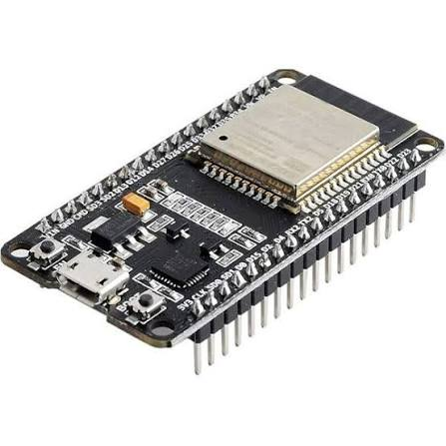
FIGURE 4.1
4.5.2 DS18B20 Temperature Sensors
The DS18B20 is a digital temperature sensor known for its high accuracy and ease of interfacing. It operates using a one-wire communication protocol, allowing multiple sensors to be connected using a single data line. In this project, two DS18B20 sensors are used—one for indoor temperature measurement and the other for outdoor temperature measurement.

The sensor provides temperature readings with an accuracy of ±0.5 °C and is suitable for both indoor and outdoor environments. Its digital output eliminates the need for external analog-to-digital converters, improving measurement reliability.
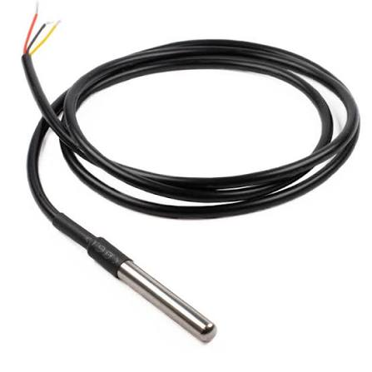

FIGURE 4.2
4.5.3 RTC Module (DS3231)
The DS3231 Real-Time Clock module is used to maintain accurate date and time information. It ensures that each temperature reading is time-stamped, enabling detailed analysis of temperature variations over time.

The DS3231 offers high accuracy and includes a backup battery to retain time information during power interruptions. This feature is essential for continuous and long-term data logging applications.
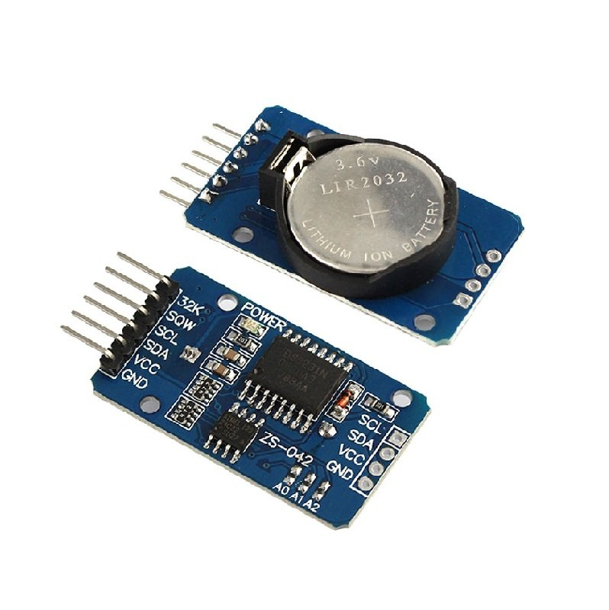
FIGURE 4.3

4.5.4 SD Card Module
The SD card module is used for storing temperature data collected by the system. The data is saved in a readable format, allowing easy transfer to a computer for analysis. This module enables long-term storage of large datasets without memory limitations.

The SD card module communicates with the ESP32 using the SPI protocol. The stored data is later used to generate graphs and compare indoor and outdoor temperature trends.

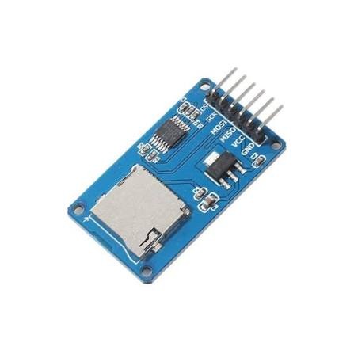
FIGURE 4.4

4.5.5 Power Supply Unit
The power supply unit provides regulated voltage to all electronic components in the system. A stable power supply is essential for accurate sensor readings and reliable system operation.

The system can be powered using a DC adapter or a rechargeable battery, depending on application requirements. Voltage regulation ensures safe operation of the ESP32 and peripheral modules.


FIGURE 4.5

4.5.6 Passive Cooling Structural Elements
The passive cooling structural elements form the core of the cooling system. Reflective roofing materials are used to minimize solar heat absorption. Thermal insulation materials such as thermocol are placed beneath the roof to reduce conductive heat transfer.

Ventilation openings are strategically placed to facilitate natural airflow and heat dissipation. Shading elements are provided to block direct solar radiation on walls and windows. These structural elements work together to reduce indoor heat gain and improve thermal comfort.

4.6 Design Considerations
Several design considerations are taken into account while developing the system:
- Selection of low-cost and locally available materials
- Proper placement of temperature sensors to avoid direct sunlight exposure
- Adequate ventilation for effective heat dissipation
- Reliable power supply for continuous operation
- Easy assembly and scalability of the system

4.7 System Advantages
- Low energy consumption
- Environmentally friendly operation
- Accurate temperature monitoring
- Cost-effective design
- Easy implementation for residential applications

CHAPTER 5
CIRCUIT DESIGN AND CONNECTIONS

5.1 Introduction
The circuit design plays a vital role in the effective operation of the passive cooling monitoring system. The purpose of the circuit is to continuously measure indoor and outdoor temperatures and store the data for performance analysis of the passive cooling techniques used in the building model. The circuit is designed to be simple, reliable, low-power, and suitable for long-term operation.

The electronic circuit integrates a microcontroller, temperature sensors, real-time clock module, and a data storage unit. Each component is selected based on accuracy, compatibility, and ease of interfacing. The circuit ensures synchronized data acquisition and safe power distribution to all modules.

5.2 Circuit Diagram
The circuit diagram illustrates the electrical connections between the ESP32 microcontroller and the peripheral components. The ESP32 acts as the control unit, receiving temperature data from sensors and managing data storage operations.

Two DS18B20 digital temperature sensors are connected to the ESP32 using a one-wire communication protocol. The real-time clock (RTC) module is interfaced through the I²C protocol to maintain accurate timing information. An SD card module is connected using the SPI protocol to store temperature data.
All components are powered using a regulated power supply, and a common ground is maintained across the circuit to ensure stable and noise-free operation

5.3 Pin Configuration of ESP32
The ESP32 microcontroller provides multiple GPIO pins that support digital communication protocols. Proper pin allocation is essential to avoid conflicts and ensure smooth operation of the system.

S. No. | ESP32 Pin | Function | Connected Module
1 | GPIO 4 | Data line (One-Wire) | DS18B20 Temperature Sensors
2 | GPIO 21 (SDA) | I²C Data Line | RTC Module (DS3231)
3 | GPIO 22 (SCL) | I²C Clock Line | RTC Module (DS3231)
4 | GPIO 5 (CS) | Chip Select | SD Card Module
5 | GPIO 18 (SCK) | SPI Clock | SD Card Module
6 | GPIO 23 (MOSI) | SPI Master Out Slave In | SD Card Module
7 | GPIO 19 (MISO) | SPI Master In Slave Out | SD Card Module
8 | 3.3 V & GND | Power Supply | All Sensors and Modules

5.4 Sensor Wiring and Connections
The DS18B20 digital temperature sensors are connected using a one-wire communication interface. Each sensor has three terminals: VCC, DATA, and GND.
- VCC is connected to the 3.3 V output of the ESP32
- GND is connected to the common ground
- DATA is connected to GPIO 4 of the ESP32
A 4.7 kΩ pull-up resistor is connected between the DATA line and VCC to ensure reliable communication. One sensor is placed inside the structure to measure indoor temperature, and the second sensor is placed outside to measure ambient temperature. Sensors are positioned away from direct sunlight and moisture to prevent measurement errors.

5.5 RTC Module Connections
The DS3231 RTC module is interfaced with the ESP32 through the I²C communication protocol. This protocol requires only two signal lines, making it efficient and reliable.
- SDA pin of RTC → GPIO 21 of ESP32
- SCL pin of RTC → GPIO 22 of ESP32
- VCC → 3.3 V supply
- GND → Common ground
The RTC module includes a backup battery that maintains time information during power loss. Accurate time-stamping of temperature readings allows detailed performance analysis of the passive cooling system.

5.6 SD Card Module Connections
The SD card module is used for long-term storage of temperature data. It is connected to the ESP32 using the SPI protocol, which enables high-speed data transfer.
- CS (Chip Select) → GPIO 5
- MOSI → GPIO 23
- MISO → GPIO 19
- SCK → GPIO 18
- VCC → 3.3 V
- GND → Common ground
The data is stored in text or CSV format, making it easy to analyze using a computer. Proper initialization of the SD card is performed during system startup to ensure error-free data logging.

5.7 Power Supply Arrangement
A regulated power supply is used to provide stable voltage to all components. The ESP32 and peripheral modules operate at 3.3 V, ensuring low power consumption and safety.

The power supply may be derived from a DC adapter, USB source, or battery. Voltage regulation prevents damage to components and ensures consistent sensor performance. Decoupling capacitors are used to reduce electrical noise and voltage fluctuations.

5.8 Circuit Reliability and Safety Measures
Several measures are implemented to enhance the reliability and safety of the circuit:
- Use of regulated voltage supply
- Proper grounding of all components
- Secure wiring connections to prevent short circuits
- Insulation of exposed terminals
- Protection of sensors from environmental exposure

CHAPTER 6
WORKING PRINCIPLE

6.1 Introduction
The working principle of the proposed passive cooling system is based on reducing heat gain and enhancing heat dissipation using natural processes, combined with continuous temperature monitoring for performance evaluation. Unlike conventional cooling systems that rely on electrical energy, this system utilizes passive cooling techniques integrated with an embedded monitoring setup to achieve thermal comfort.

The system works by minimizing solar heat absorption, reducing conductive heat transfer, promoting natural ventilation, and continuously measuring indoor and outdoor temperature variations. The embedded system collects temperature data at regular intervals, enabling accurate analysis of the cooling performance.

  - Heat Transfer Mechanism in Passive Cooling
The passive cooling system operates on the fundamental principles of heat transfer, namely conduction, convection, and radiation.
- Conduction: Heat enters the building through roofs and walls due to temperature differences between the outdoor and indoor environments. The use of insulation materials reduces the rate of heat transfer by conduction.
- Convection: Natural airflow removes warm air from the indoor space and replaces it with cooler outdoor air. Ventilation openings facilitate convective heat removal.
- Radiation: Solar radiation is a major source of heat gain. Reflective roofing and wall surfaces reduce radiative heat absorption by reflecting a large portion of incident solar energy.
- By controlling these heat transfer mechanisms, the passive cooling system effectively lowers indoor temperatures without consuming electrical energy.

  - Passive Cooling Operation
During daytime, solar radiation heats the external surfaces of the building. The reflective roof materials reduce heat absorption, while the insulation layer limits heat conduction into the interior. Shading elements prevent direct sunlight from entering through openings, reducing indoor heat gain.

As indoor air warms, it becomes lighter and rises, escaping through higher ventilation openings. Cooler air enters through lower openings, creating natural airflow and enhancing convective cooling. This continuous air exchange helps maintain a lower and more stable indoor temperature.

At night, when ambient temperatures drop, the stored heat within building materials is released to the surroundings. This process, known as night-time heat dissipation, further improves thermal comfort.

  - Temperature Sensing Process
The temperature monitoring system continuously measures indoor and outdoor temperatures using DS18B20 digital temperature sensors. One sensor is placed inside the structure to record indoor temperature, while the other sensor measures ambient outdoor temperature.

The sensors convert temperature values into digital signals and transmit them to the ESP32 microcontroller. The ESP32 processes the sensor data and prepares it for storage. The high accuracy of the sensors ensures reliable and consistent temperature measurements.

  - Data Logging and Time Synchronization
To ensure accurate time-based analysis, a real-time clock (RTC) module is used for time synchronization. The RTC provides precise date and time information, which is appended to each temperature reading.

The ESP32 records temperature data at fixed intervals, typically every one minute. The collected data, along with time stamps, is stored in an SD card in a structured format. This continuous data logging enables detailed analysis of temperature variations throughout the day.

  - System Operation Flow
- The overall system operation follows a sequential process:
- Power supply is provided to the ESP32 and peripheral modules
- The ESP32 initializes the temperature sensors, RTC, and SD card
- Indoor and outdoor temperatures are measured
- Time information is obtained from the RTC module
- Temperature data is stored on the SD card
- The process repeats at fixed time intervals

CHAPTER 7
EXPERIMENTAL SETUP AND IMPLEMENTATION

7.1 Introduction
The experimental setup is developed to practically evaluate the performance of the proposed passive cooling system for residential buildings. The experiment aims to measure and compare indoor and outdoor temperature variations using a prototype model integrated with passive cooling elements and an embedded temperature monitoring system. This experimental validation is essential to verify the effectiveness of passive cooling techniques under real environmental conditions.

The implementation focuses on accuracy, repeatability, and continuous data collection. Temperature measurements are recorded at fixed time intervals to analyze the thermal behavior of the structure throughout the day.

7.2 Description of Experimental Model
A scaled prototype model representing a residential building was constructed using lightweight and thermally stable materials. The model consists of walls, a roof, ventilation openings, and shading provisions to closely resemble a conventional residential structure. The roof is designed with reflective material to reduce solar heat absorption, while ventilation openings are strategically positioned to promote natural airflow and effective heat dissipation. Shading provisions are included to limit direct exposure to solar radiation. The entire prototype is mounted on a stable base to ensure safety and stability during experimental observations.

S. No. | Parameter | Description
1 | Prototype Model Type | Scaled residential building model
2 | Construction Material | Lightweight and thermally stable materials
3 | Structural Components | Walls, roof, ventilation openings, and shading provisions
4 | Roof Design | Reflective roofing material to minimize solar heat absorption
5 | Ventilation Arrangement | Strategically placed openings for natural airflow and heat dissipation
6 | Shading Provisions | External shading to reduce direct solar radiation
7 | Mounting Arrangement | Mounted on a stable base for safety and experimental stability

7.3 Integration of Passive Cooling Techniques
- Reflective Roofing: Used to reflect incident solar radiation and reduce surface temperature.
- Thermal Insulation: Installed below the roof to minimize heat conduction into the indoor space.
- Natural Ventilation: Ventilation openings allow warm air to escape and cooler air to enter.
- Shading Elements: Prevent direct sunlight from entering the structure through openings.
The combined application of these techniques helps reduce indoor heat gain and improves thermal comfort.
7.4 Temperature Sensor Installation
Two DS18B20 digital temperature sensors are used for temperature measurement. One sensor is installed inside the prototype at the center of the indoor space to measure internal temperature. The sensor is mounted at a height that avoids direct exposure to roof heat and airflow disturbances.

The second sensor is placed outside the prototype to measure ambient temperature. It is positioned in a shaded and well-ventilated area to avoid direct solar radiation and external heat sources. Proper sensor placement ensures accurate and reliable temperature data.

7.5 Hardware Setup
The hardware setup includes an ESP32 microcontroller, DS18B20 temperature sensors, an RTC module, and an SD card module. All components are mounted securely on a breadboard or custom PCB. Electrical connections are made according to the designed circuit diagram.

The ESP32 is programmed to read temperature values from both sensors at regular intervals. The RTC module provides accurate date and time information, while the SD card module stores the recorded data. A regulated power supply is used to power the entire system, ensuring stable operation.

7.6 Software Implementation
The software is developed using the Arduino IDE. During system initialization, the ESP32 checks the availability of sensors, RTC, and SD card modules. After successful initialization, the system enters continuous operation mode.

Temperature readings are recorded at one-minute intervals. Each reading is time-stamped using the RTC module and stored on the SD card in a structured format. The program includes error-checking routines to ensure reliable data logging.

7.7 Calibration and Testing
Before conducting the main experiment, the temperature sensors are calibrated using a standard digital thermometer. Calibration is carried out under controlled conditions to verify sensor accuracy. Any deviation between sensor readings and reference values is noted and corrected through software adjustments.

Preliminary testing is conducted to ensure proper functioning of all components and to verify correct data storage on the SD card.

7.8 Experimental Procedure
- The prototype model is placed in an open area exposed to natural environmental conditions.
- The temperature monitoring system is powered ON and allowed to stabilize.
- Indoor and outdoor temperatures are recorded continuously at one-minute intervals.
- Data collection is carried out during peak daytime hours.
- After completion, the system is powered OFF and data is retrieved from the SD card.
This procedure ensures consistent and reliable data collection.

7.9 Data Collection and Analysis Preparation
The recorded temperature data includes date, time, indoor temperature, and outdoor temperature. The data is transferred from the SD card to a computer for further analysis.
Graphs and tables are prepared to compare indoor and outdoor temperature variations. These comparisons help in evaluating the cooling effectiveness and thermal stability provided by the passive cooling system.

CHAPTER 8
COST ESTIMATION

8.1 Introduction
Cost estimation is an important aspect of any engineering project, as it helps determine the economic feasibility and practicality of the proposed system. The objective of cost estimation in this project is to evaluate the total expenditure involved in developing the passive cooling prototype and the associated temperature monitoring system.

The proposed system is designed using low-cost, easily available materials and components to ensure affordability and suitability for residential applications. The cost estimation includes expenses related to electronic components, structural materials, and miscellaneous items required for implementation.

8.2 Cost Estimation Methodology
The cost estimation is carried out by identifying all the components used in the project and calculating their individual costs based on current market prices. The total cost is obtained by summing the cost of all components.
The estimation focuses on:
- Selection of economical electronic components
- Use of locally available materials for passive cooling
- Minimization of unnecessary expenses
- Achieving maximum performance at minimum cost
This approach ensures that the proposed passive cooling system remains cost-effective and practical.

8.3 Component-Wise Cost Breakdown
Table 8.3 Cost Estimation of Components
S. No. | Component / Material | Quantity | Cost per Unit (₹) | Total Cost (₹)
1 | Cardboard (5 ft × 5 ft) | 1 sheet | 500 | 500
2 | ESP32 Microcontroller | 1 | 400 | 400
3 | DS18B20 Temperature Sensor | 3 | 400 | 1200
4 | SD Card Module with SD Card | 1 | 200 | 200
5 | RTC Module (DS3231) | 1 | 200 | 200
6 | Jumper Wires | 1 set | 80 | 80
7 | Aluminium Foil Sheet | 1 roll | 100 | 100
8 | Charger with Cable | 1 | 500 | 500
9 | Glue Gun | 1 | 150 | 150
10 | Glue Gun Sticks | 10 | 10 | 100
 | Total Cost |  |  | 3430

8.4 Economic Feasibility
The total estimated cost of the proposed system is relatively low compared to conventional mechanical cooling systems such as air conditioners. Once implemented in real residential buildings, passive cooling techniques significantly reduce electricity consumption, leading to long-term cost savings.

The temperature monitoring system requires minimal power and maintenance, further reducing operational costs. The use of low-cost materials and simple construction methods makes the system affordable for widespread adoption.

8.5 Cost Comparison with Conventional Cooling Systems
Conventional air conditioning systems involve high initial costs, continuous electricity consumption, and regular maintenance expenses. In contrast, the proposed passive cooling system has:
- Low initial installation cost
- Negligible operating cost
- No recurring electricity expense for cooling
- Minimal maintenance requirements
This makes passive cooling a financially attractive alternative, especially in tropical and energy-constrained regions.

CHAPTER 9
RESULTS AND ANALYSIS

9.1 Introduction
This chapter presents the experimental results obtained from the passive cooling system implemented on the prototype model and provides a detailed analysis of its performance. The primary objective of the experiment is to evaluate the effectiveness of passive cooling techniques in reducing indoor temperature and improving thermal comfort.

The temperature data collected using the embedded monitoring system is analyzed to compare indoor and outdoor temperature variations over different periods of the day. Graphical and tabular representations are used to clearly illustrate the performance of the system.

9.2 Temperature Data Collection
Temperature data is collected continuously at one-minute intervals using DS18B20 digital temperature sensors. One sensor measures the indoor temperature inside the prototype model, while the other measures the ambient outdoor temperature.

The data is recorded with accurate time stamps using the RTC module and stored on the SD card. Continuous monitoring enables detailed analysis of temperature trends and helps identify peak temperature periods during the day.

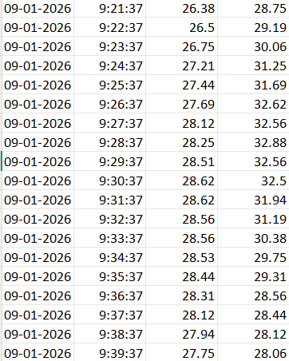

FIGURE 9.1

9.3 Indoor and Outdoor Temperature Comparison
The collected data shows a clear difference between indoor and outdoor temperatures. During peak daytime hours, the outdoor temperature increases rapidly due to direct solar radiation. However, the indoor temperature rises at a slower rate due to the presence of passive cooling elements.

The results indicate that the indoor temperature remains consistently lower than the outdoor temperature throughout the day. This temperature difference demonstrates the effectiveness of reflective roofing, insulation, shading, and natural ventilation in reducing heat gain.

9.4 Performance During Peak Temperature Hours
The performance of the passive cooling system is most evident during peak temperature hours, typically between 12:00 PM and 3:00 PM. During this period, the outdoor temperature reaches its maximum value.

Experimental results show that the indoor temperature is reduced by approximately 5 to 7 °C compared to the outdoor temperature during peak hours. This reduction confirms that passive cooling techniques significantly improve indoor thermal comfort without the use of mechanical cooling systems.

9.5 Temperature Stability Analysis
In addition to temperature reduction, the system also provides improved thermal stability. The indoor temperature shows fewer fluctuations compared to the outdoor temperature, indicating effective thermal mass and insulation behavior.

The reduced rate of temperature change inside the structure demonstrates the ability of passive cooling elements to delay heat transfer. This stable indoor environment enhances occupant comfort and reduces thermal stress.

9.6 Graphical Representation of Results
Graphs plotted using the recorded data show clear trends in temperature variation. The outdoor temperature curve exhibits sharp peaks and fluctuations due to changing environmental conditions. In contrast, the indoor temperature curve remains smoother and consistently lower.

The graphical comparison highlights the time lag between outdoor temperature rise and indoor temperature response, which is a key indicator of effective passive cooling.

9.7 Effectiveness of Individual Passive Cooling Techniques
The experimental results suggest that each passive cooling technique contributes to overall performance:
- Reflective Roofing: Significantly reduces solar heat absorption
- Thermal Insulation: Minimizes conductive heat transfer
- Natural Ventilation: Enhances convective heat removal
- Shading Elements: Prevents direct solar radiation

9.8 Energy Saving Potential
The observed indoor temperature reduction reduces the need for mechanical cooling devices such as air conditioners and fans. This directly translates into energy savings and lower electricity consumption.

The passive cooling system operates without continuous power input, making it an energy-efficient and environmentally friendly solution for residential buildings.

9.9 Limitations of the Experiment
- The experiment is conducted on a scaled prototype model
- Environmental conditions may vary on different days
- Long-term seasonal performance is not analyzed

CHAPTER 10
ADVANTAGES AND APPLICATIONS

10.1 Introduction
Passive cooling systems provide an effective alternative to conventional mechanical cooling methods by utilizing natural heat transfer mechanisms and architectural design strategies. The proposed passive cooling system for homes offers several technical, economic, and environmental benefits.

This chapter discusses the major advantages of the system and its potential applications in residential and other building sectors.

10.2 Advantages of Passive Cooling System
10.2.1 Energy Efficiency
One of the primary advantages of passive cooling systems is their ability to operate without continuous electrical energy input. The system reduces indoor temperature by minimizing heat gain and enhancing natural heat dissipation. As a result, dependence on electrical cooling devices such as air conditioners and fans is significantly reduced, leading to substantial energy savings.

10.2.2 Cost Effectiveness
The proposed system is developed using low-cost and locally available materials such as reflective roofing sheets, insulation materials, and natural ventilation openings. Unlike conventional cooling systems, passive cooling does not require expensive equipment or frequent maintenance. This makes it economically feasible for residential applications, especially in low- and middle-income households.

10.2.3 Environmentally Friendly
Passive cooling systems do not use refrigerants or generate greenhouse gas emissions during operation. By reducing electricity consumption, the system indirectly lowers carbon emissions associated with power generation. This contributes to environmental protection and supports sustainable development goals.

10.2.4 Improved Thermal Comfort
The system maintains a more stable indoor temperature by reducing temperature fluctuations throughout the day. The combined effect of insulation, ventilation, shading, and reflective surfaces creates a comfortable indoor environment. Improved thermal comfort enhances occupant well-being and productivity.

10.2.5 Low Maintenance Requirements
Passive cooling systems have minimal moving parts or electronic components, resulting in low maintenance requirements. Once installed, the system operates continuously without the need for frequent servicing. This increases system reliability and reduces long-term operational costs.

10.2.6 Scalability and Adaptability
The passive cooling techniques used in this project can be easily scaled and adapted to different building sizes and climatic conditions. The system can be implemented in both new constructions and existing buildings with minor modifications.

10.3 Applications of Passive Cooling System
10.3.1 Residential Buildings
The primary application of the proposed system is in residential buildings such as individual houses, apartments, and rural homes. Passive cooling is particularly effective in tropical and subtropical regions, where high temperatures prevail for most of the year.

10.3.2 Rural and Low-Income Housing
Passive cooling systems are well suited for rural and low-income housing due to their low cost and minimal energy requirements. The use of locally available materials and simple construction techniques makes the system accessible to economically weaker sections.

10.3.3 Commercial Buildings
Passive cooling techniques can also be applied to small commercial buildings such as shops, offices, and retail spaces. Reducing cooling energy demand in commercial buildings leads to lower operational costs and improved sustainability.

10.3.4 Educational Institutions
Schools, colleges, and training centers can benefit from passive cooling systems by providing comfortable learning environments while minimizing energy consumption. Large classroom spaces can be effectively cooled using natural ventilation and shading techniques.

10.3.5 Industrial and Storage Buildings
Passive cooling methods are suitable for warehouses, storage facilities, and industrial buildings where maintaining moderate temperatures is essential. These systems help protect stored goods and improve working conditions without high energy costs.

11. APPENDICES

11.1 FIELD VISIT
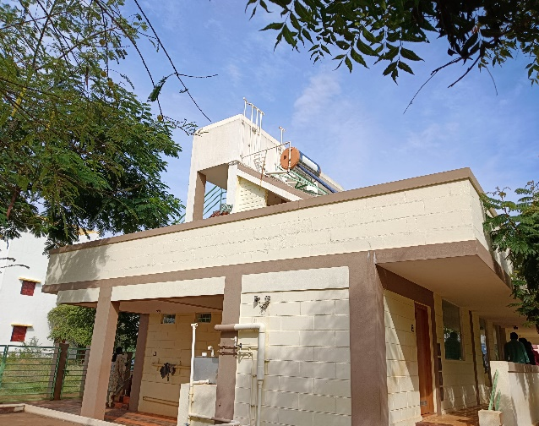
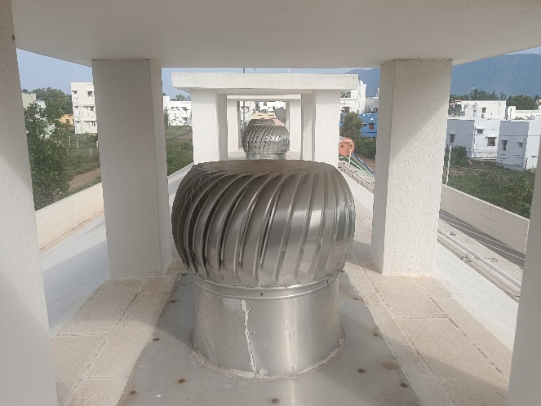
FIGURE 11.1 FIGURE 11.2

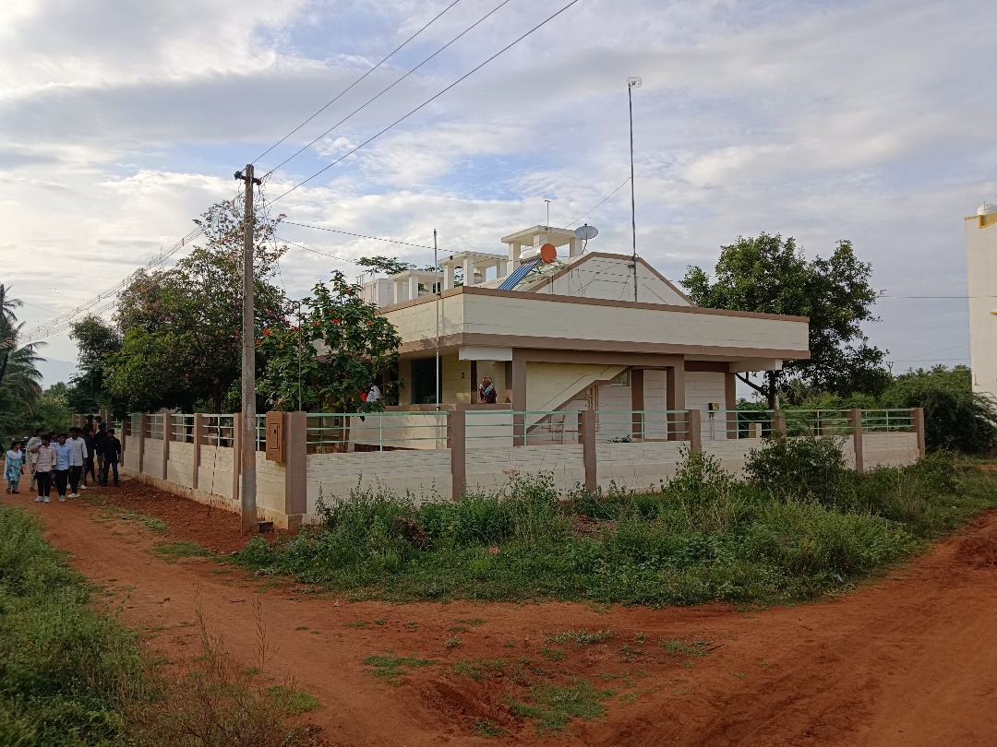
FIGURE 11.3

11.2 PROTOTYPE

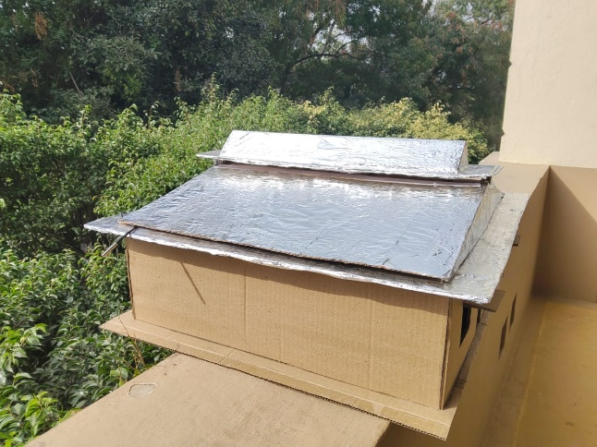
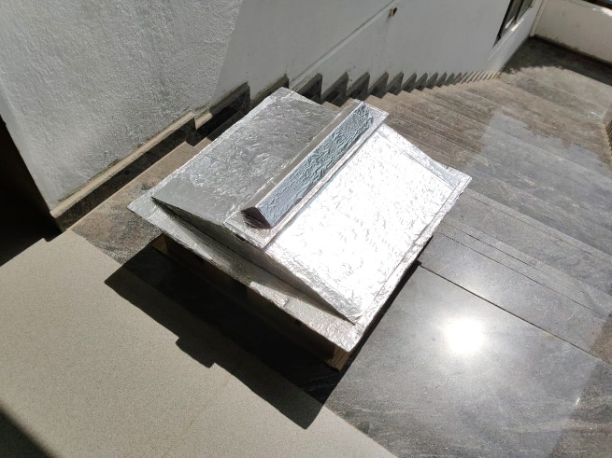

FIGURE 11.4 FIGURE 11.5

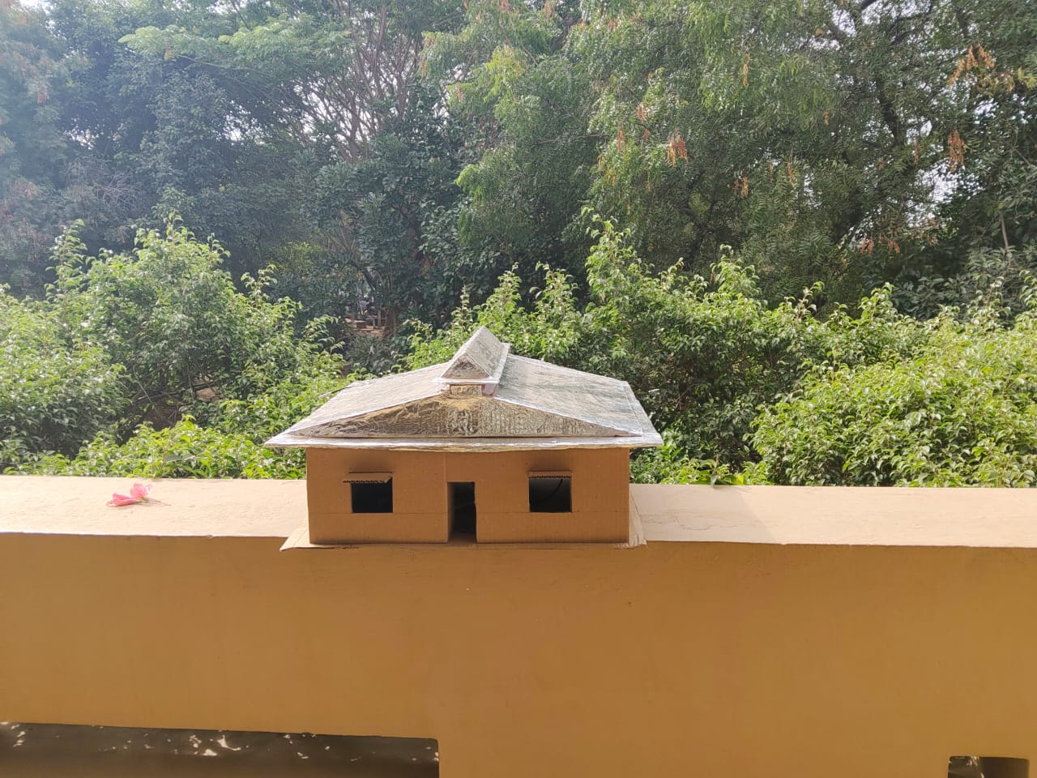

FIGURE 11.6

12 .CONCLUSION
This project successfully demonstrates the design, implementation, and performance evaluation of a Passive Cooling System for Homes aimed at reducing indoor temperatures in tropical and high-temperature regions. The increasing dependence on mechanical cooling systems such as air conditioners and electric fans has led to higher energy consumption, increased operational costs, and adverse environmental impacts. In this context, passive cooling techniques offer a sustainable and energy-efficient alternative.The proposed system integrates multiple passive cooling strategies, including thermal insulation, reflective materials, enhanced natural ventilation, and controlled heat exchange, to minimize indoor heat gain. To experimentally evaluate the effectiveness of the passive cooling approach, an ESP32-based temperature monitoring system was developed using two DS18B20 digital temperature sensors, with one sensor placed inside the structure and the other outside. Temperature data was recorded at one-minute intervals using a Real-Time Clock (RTC) module and stored on an SD card, enabling accurate and high-resolution thermal analysis.Experimental results clearly indicate that the passive cooling prototype achieves a significant indoor temperature reduction of approximately 5 to 7 °C compared to the outdoor environment, particularly during peak daytime hours. Additionally, the indoor temperature was observed to be more stable than the outdoor temperature, confirming the effectiveness of the integrated passive cooling techniques in improving thermal comfort. The results validate that passive cooling methods can substantially reduce reliance on energy-intensive mechanical cooling systems.Overall, the proposed passive cooling system proves to be cost-effective, energy-efficient, and environmentally sustainable, making it highly suitable for residential buildings in tropical and energy-constrained regions. The project highlights the potential of passive cooling as a practical solution for achieving thermal comfort while contributing to energy conservation and environmental protection.
13.REFERENCES

[1] B. Givoni, Man, Climate and Architecture, 2nd ed. London, UK: Applied Science Publishers, 1976.

[2] V. Olgyay, Design with Climate: Bioclimatic Approach to Architectural Regionalism. Princeton, NJ, USA: Princeton University Press, 1963.

[3] ASHRAE, ASHRAE Handbook—Fundamentals. Atlanta, GA, USA: American Society of Heating, Refrigerating and Air-Conditioning Engineers, 2009.

[4] M. Santamouris and D. Kolokotsa, “Passive cooling dissipation techniques for buildings and other structures: The state of the art,” Energy and Buildings, vol. 57, pp. 74–94, 2013.

[5] M. Santamouris, “Cooling the buildings—Past, present and future,” Energy and Buildings, vol. 128, pp. 617–638, 2016.

[6] J. Yang, Z. Wang, and X. Zhang, “Thermal performance of cool roofs and its impact on energy consumption,” Applied Energy, vol. 204, pp. 406–417, 2017.

[7] A. Z. S. Sadineni, S. Madala, and R. F. Boehm, “Passive building energy savings: A review of building envelope components,” Renewable and Sustainable Energy Reviews, vol. 15, no. 8, pp. 3617–3631, 2011.

[8] L. Pisello and F. Cotana, “The role of cool roof technology in passive cooling of buildings,” Energy and Buildings, vol. 123, pp. 203–214, 2016.

[9] A. Hasan, “Phase change materials for thermal regulation of buildings and domestic applications,” Energy and Buildings, vol. 35, no. 4, pp. 353–362, 2018.

[10] Y. Al-Sallal and A. Al-Rais, “Outdoor airflow analysis and natural ventilation for buildings in hot-humid climates,” Energy and Buildings, vol. 45, pp. 61–68, 2012.

[11] M. Kolokotroni, R. Giridharan, and S. Watkins, “The impact of urban heat island on building cooling demand,” Solar Energy, vol. 86, no. 1, pp. 307–317, 2012.

[12] F. Ascione et al., “Energy refurbishment of existing buildings through passive cooling strategies,” Applied Energy, vol. 162, pp. 1457–1473, 2016.

[13] H. Akbari and S. Kolokotsa, “Three decades of urban heat islands and mitigation technologies,” Energy and Buildings, vol. 133, pp. 834–852, 2016.

[14] A. De Angelis et al., “Thermal performance of ventilated roofs in Mediterranean climates,” Energy and Buildings, vol. 202, 2019.

[15] M. Zinzi and S. Agnoli, “Cool roof research and development: State of the art,” Advances in Building Energy Research, vol. 6, no. 1, pp. 51–77, 2012.

[16] P. La Roche, Carbon-Neutral Architectural Design. Boca Raton, FL, USA: CRC Press, 2017.

[17] A. A. Omar and M. A. Abdelrahman, “Performance of earth–air heat exchangers for residential buildings,” Energy and Buildings, vol. 199, pp. 193–205, 2019.

[18] S. Bojic et al., “Night ventilation and thermal mass effects on building cooling,” Energy and Buildings, vol. 38, no. 7, pp. 831–836, 2006.

[19] J. R. Turnpenny et al., “Numerical modeling of PCM-enhanced building components,” Applied Energy, vol. 86, no. 4, pp. 688–695, 2009.

[20] A. Erell, E. Pearlmutter, and T. Williamson, Urban Microclimate: Designing the Spaces Between Buildings. London, UK: Earthscan, 2011.

[21] R. Levinson et al., “Solar-reflective roofs for mitigating the urban heat island effect,” Energy and Buildings, vol. 150, pp. 16–25, 2017.

[22] S. Raman et al., “Passive radiative cooling below ambient air temperature under direct sunlight,” Nature, vol. 515, pp. 540–544, 2014.

[23] X. Zhang et al., “Passive radiative cooling for buildings,” Energy and Environmental Science, vol. 11, pp. 144–158, 2018.

[24] P. Berdahl et al., “Thermal performance of radiative cooling materials,” Solar Energy Materials and Solar Cells, vol. 188, pp. 71–80, 2018.

[25] M. Dereń et al., “Passive radiant cooling without sacrificing the aesthetics of objects,” Advanced Optical Materials, vol. 10, no. 12, 2022.

[26] X. Zhang et al., “Highly emissive, selective and omnidirectional thermal emitters mediated by machine learning for ultrahigh performance passive radiative cooling,” Journal of Materials Chemistry A, vol. 11, no. 4, pp. 1234–1245, 2023.

[27] Y. Zhou et al., “Passive radiative cooling to sub-ambient temperatures inside naturally ventilated buildings,” Cell Reports Physical Science, vol. 4, no. 9, 2023.

[28] M. Ahmadi Moghaddam et al., “A newly designed BIPV system with enhanced passive cooling and ventilation,” Energy and Buildings, vol. 280, 2023.

[29] B. Bunker et al., “Evaluating the effectiveness of the eco-cooler for passive home cooling,” npj Climate Action, 2024.

[30] S. Li et al., “An advanced passive radiative cooling emitter with ultrahigh sub-ambient cooling performance,” Journal of Materials Chemistry A, 2024.

[31] A. Kumar et al., “Advancing sustainable building through passive cooling with phase change materials: A comprehensive review,” Renewable and Sustainable Energy Reviews, 2024.

[32] H. Wang et al., “Performance study of building cooling system composed of photovoltaic panels, PCM, and thermoelectric cooler: Impact of orientation,” International Journal of Air-Conditioning and Refrigeration, vol. 33, no. 1, 2025.

